Assignment-3
NAME: Anjali Kiran G
ROLL NUMBER:2503B05102
Task:1

Problem-01:

A bit stream 1101011011 is transmitted using the standard CRC method. The generator polynomial is x⁴+x+1. What is the actual bit string transmitted?
CODE AND COMPILATION RESULTS:-
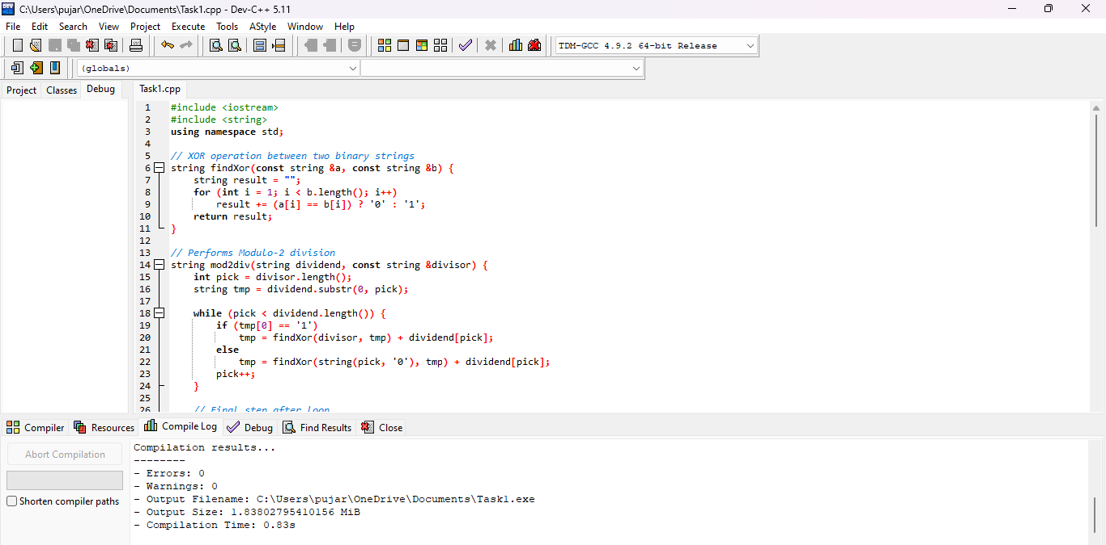

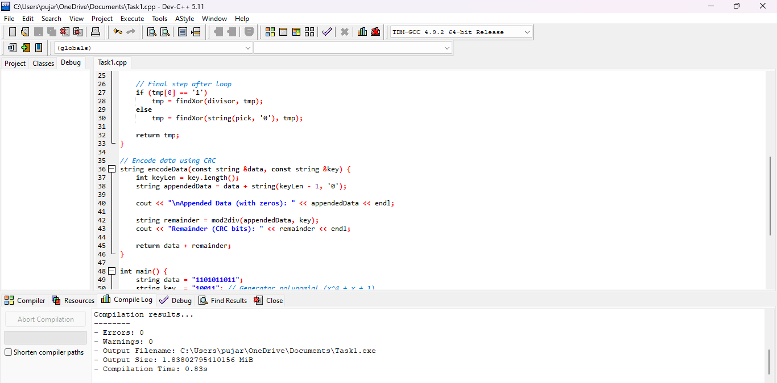

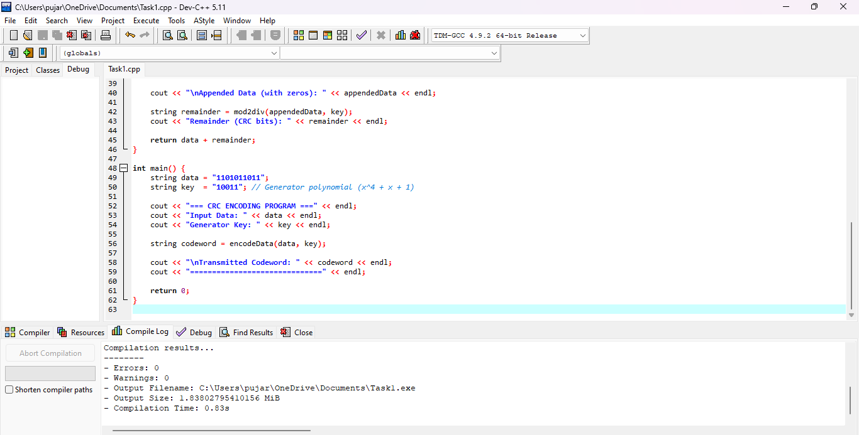

OUT PUT:-
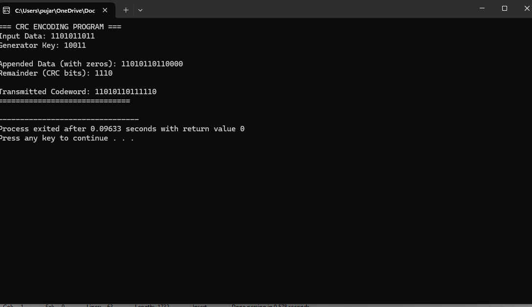

Task:2
Problem-02:
A bit stream 10011101 is transmitted using the standard CRC method. The generator polynomial is x³+1.

- What is the actual bit string transmitted?
- Suppose the third bit from the left is inverted during transmission. How will receiver detect this error?

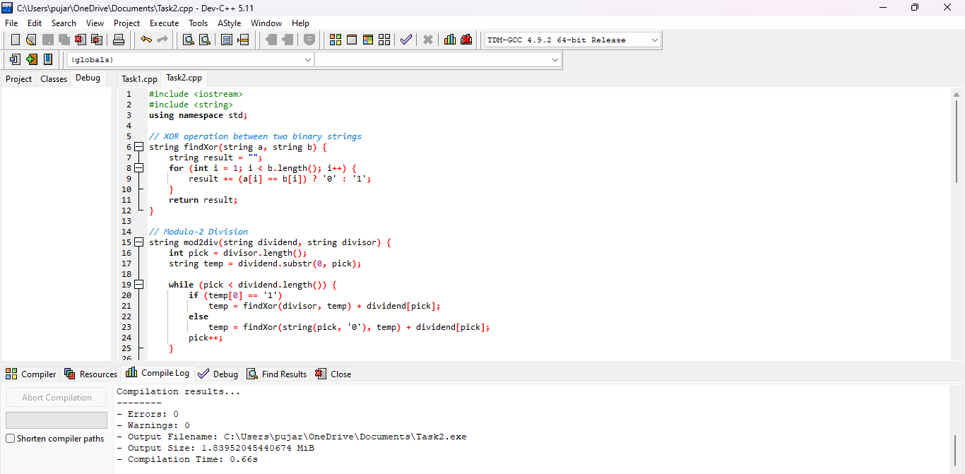

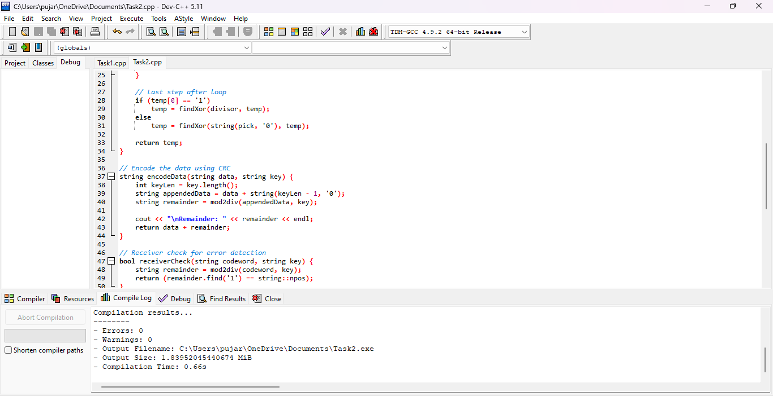
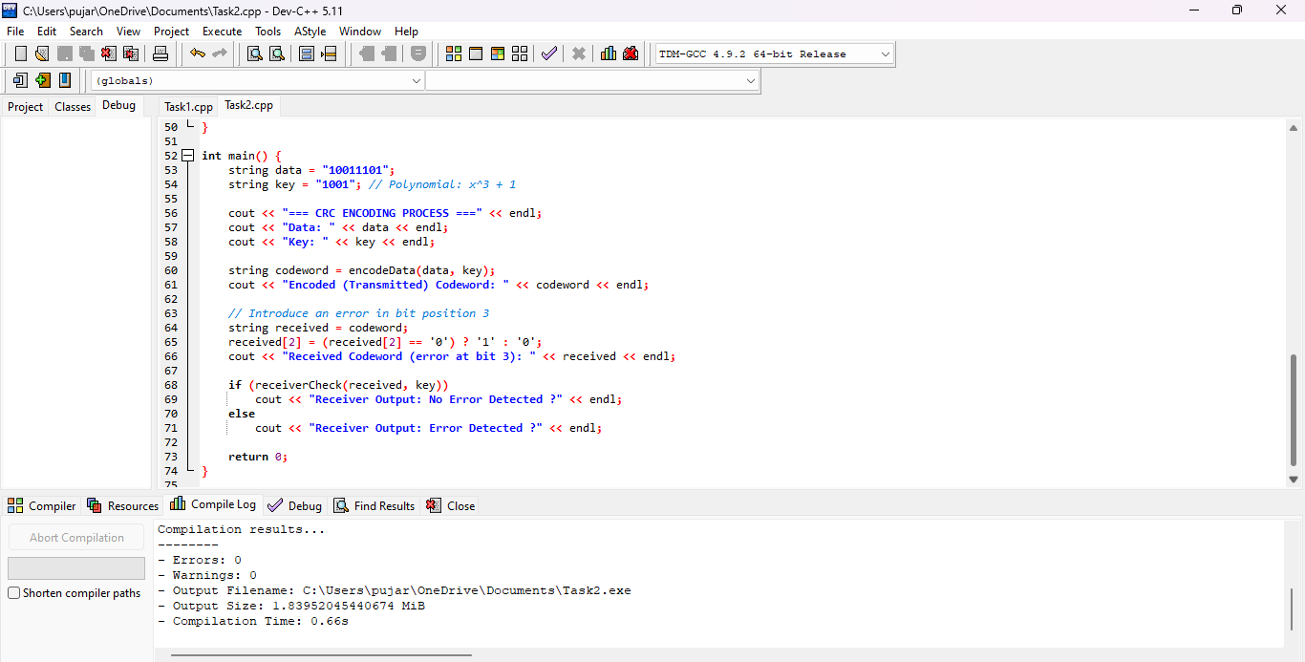
OUT PUT:-

